INTEGRATIVE COURSE IN PSYCHOLOGY (ICOPSYCH)

ANALYSIS ON THE RESULT OF POST-TEST EXAMINATION IN DEVELOPMENTAL PSYCHOLOGY
MARCH 28, 2025

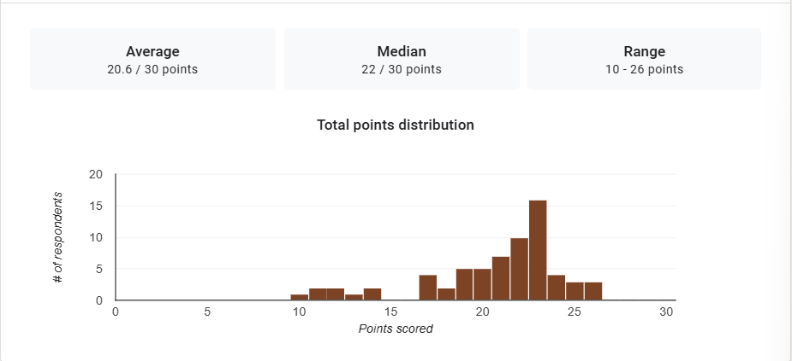

1. Mean Score: The mean score of 20.6 out of 30 suggests that the average performance of participants is above the midpoint of the possible total score (15). This indicates that, on the whole, the group performed reasonably well, though there is still room for improvement.

2. Median Score: The median score of 22 indicates that half of the participants scored above 22, while half scored below. This suggests that a significant portion of the group scored relatively high, with the middle of the distribution leaning towards the higher end of the scale.

3. Range: The range from 10 to 26 points shows that there is some variability in the performance, but the lowest score (10) is not extremely low, and the highest score (26) is relatively close to the top score of 30. This suggests that while some participants may have struggled, the majority of the group performed reasonably well, with a few high achievers.

Interpretation Summary:

-The average score of 20.6 out of 30 indicates that most participants performed above the midpoint, suggesting a generally positive level of performance.

-The median score of 22 reinforces this, indicating that a significant portion of the group scored higher than the mean, with many participants achieving results that are closer to the upper range.

-The range of 10 to 26 points indicates moderate variability in performance. While some participants did score lower (10 points), the majority performed well, and there were several high achievers with scores approaching the top score.

-Overall, the results suggest that the group’s performance is mostly strong, but there are a few individuals who may need further support or improvement. The median being higher than the mean suggests that the distribution of scores may be skewed slightly towards the higher end.

RATIONALIZATION:

DIFFICULT QUESTIONS:

